

SEVERALS operate on pressure and restraint. They do not rush statements or provide instant resolution. Tension is built deliberately, silence is part of the structure, and ideas are allowed to linger longer than expected. Rooted in modern metal, their real strength lies in atmosphere, pacing and controlled contrast.
The band has performed at major European festivals such as Rock for People and Brutal Assault, alongside extensive club experience across different territories. Their international scope was further shaped by a tour across Ukraine with Bad Omens and shows across Germany, Switzerland and more, placing SEVERALS in demanding environments where focus, precision and presence matter more than familiarity. On stage, the band remains concentrated and intentional, avoiding excess in favor of cohesion.
In the studio, SEVERALS have worked with producers Chris Kreutzfeldt and Lance Prance, refining a sound that is neither overproduced nor ornamental. Production is treated as a tool for definition rather than trend alignment, resulting in material that feels deliberate and grounded.
The current creative cycle, including the single When The Sun Is Dark, presents the band in its most distilled form. Music and visuals function as a unified system, with all visual output created internally. This approach is not driven by control for its own sake, but by continuity and clarity of intent.
SEVERALS are not built for short-term attention. They are structured for longevity, repetition and sustained focus.
Follow the Codex.

Links:
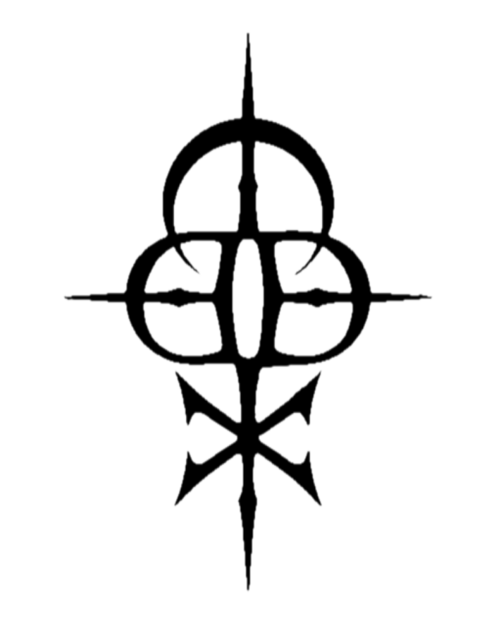
Web / Facebook / Instagram / TikTok / YouTube / Spotify / Apple Music

