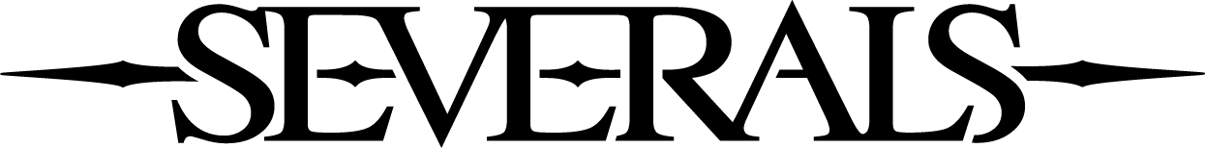

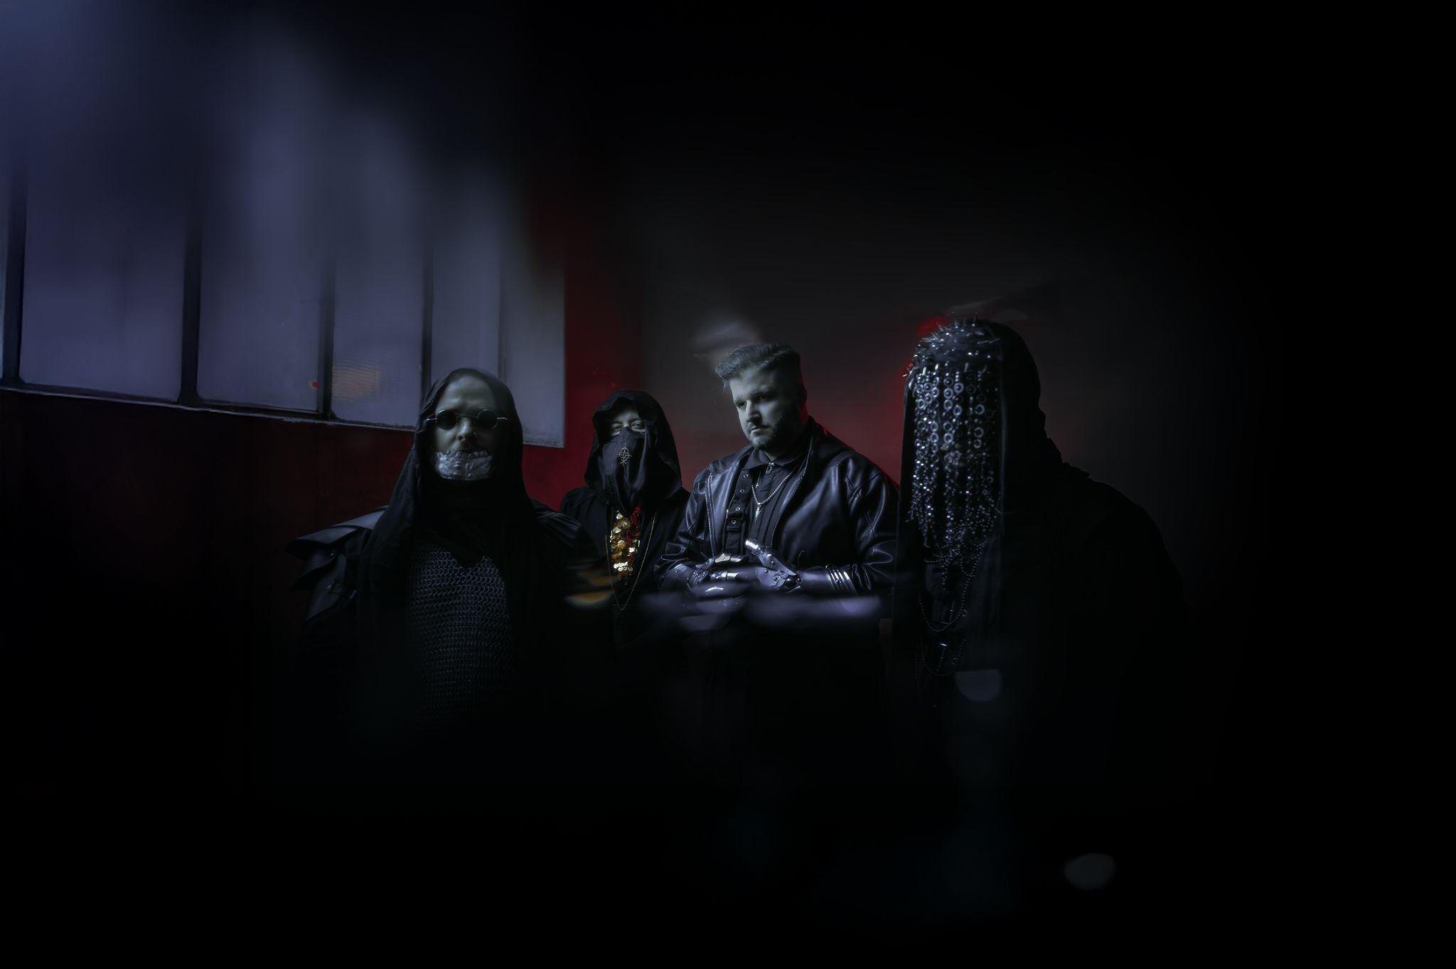

SEVERALS UNLOCK THE NIGHT IN THEIR RITUALISTIC NEW SINGLE "CLAVICULA NOX"
SEVERALS is a Czech band that builds on tension, silence, and impact as their core elements. They don’t chase trends or instant gratification. Instead, they build a carefully constructed world where sound, visuals, and intention are completely inseparable. Their music is physical, dark, and thoughtful. This is not background noise. This is a gateway.
The new single, Clavicula Nox, represents another crucial sequence in the band’s constantly evolving structure. Thematically and sonically, it is an esoteric journey—a profane cipher hidden in plain sight. While their previous work explored the abyss of isolation, this track is the very key to unlocking it. It delves into the terrifying but liberating act of crossing forbidden thresholds, unleashing pent-up violence, and embracing the darkness to become the dawn.
Lyrically, Clavicula Nox acts as an invocation rather than a mere song. It navigates through heavy, atmospheric imagery—sigils written on glass, names etched in the ether, and reflections on a sacred altar that speaks back. It is a narrative of ultimate surrender and liberation, culminating in the profound realization that there is no mercy and no hope, only the freedom found in the void. The line between the sacrifice and the ritual blurs completely as the band declares: "I'm the lock, you are the rope."
The visual language and overall presentation once again firmly connect with the music, amplifying the feeling of an otherworldly ritual and intense physical gravity. With this single, SEVERALS prove that their descent into darker, more mysterious territories is carefully calculated and relentless. Clavicula Nox is a clear signal that the band continues its uncompromising vision, turning the key to a realm where constellations fall.
Follow the Codex.
CLAVICULA NOX
Visualizer for Clavicula Nox
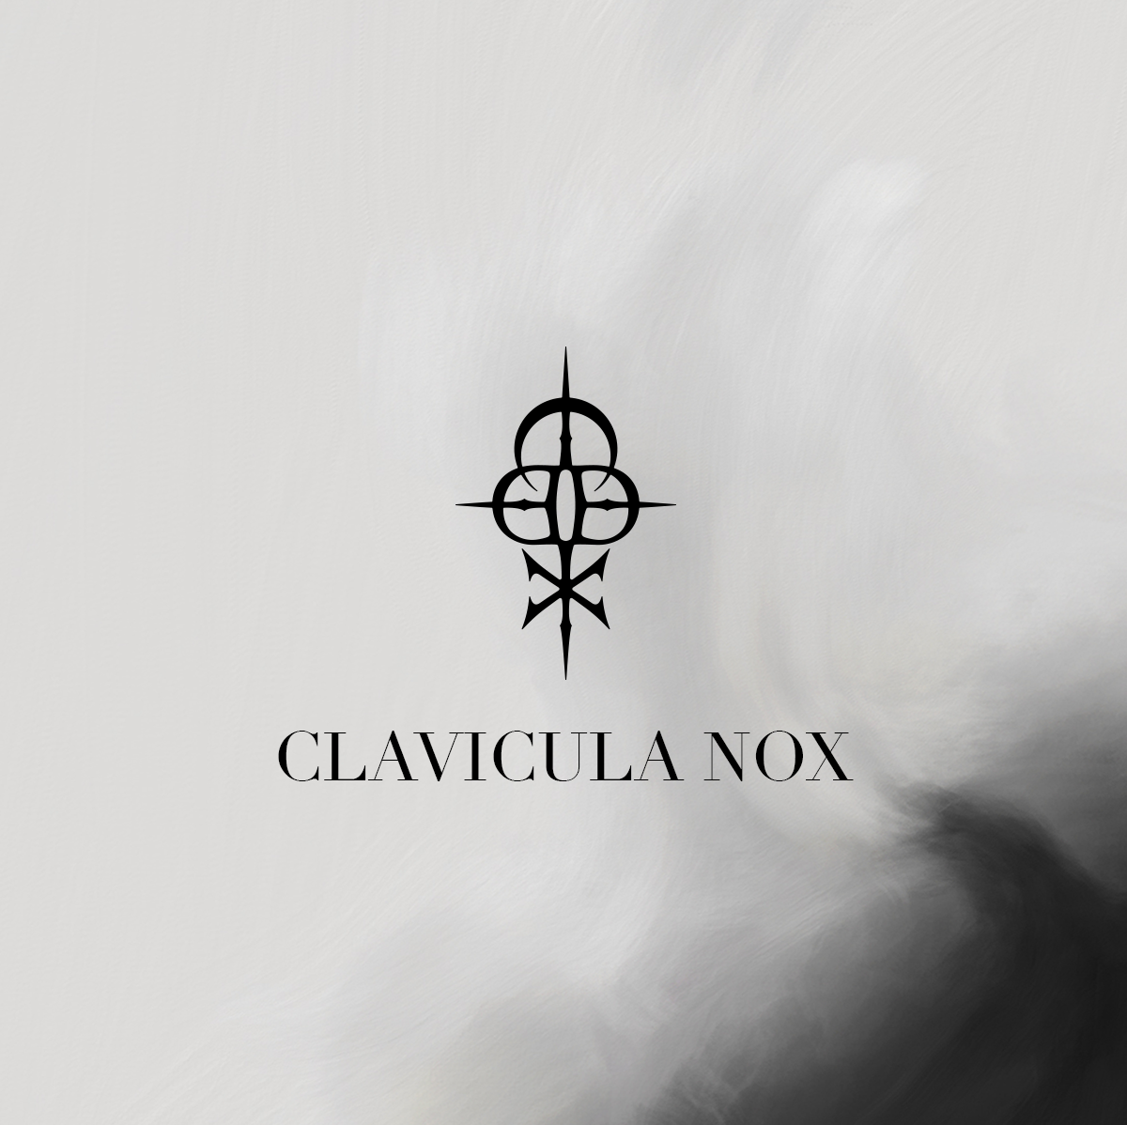
Track: Clavicula Nox
Artist: SEVERALS
ISRC code: QZTBD2694102
Release date: 10th July 2026
Composeres: Zdeněk Ziegler, Ondřej Dobrý, Jan Dietl, Dominik Fencl
Producer: Zdeněk Ziegler, Zdeněk Kaplan
Mix & master: Chris Kreutzfeldt
Artwork: Jan Dietl
Links:
Web: https://www.severalsofficial.com/home
YouTube | Spotify | Apple Music | Facebook | Instagram | TikTok

