



SEVERALS SURRENDER TO THE VOID WITH NEW SINGLE "DARK MATTER"

SEVERALS are a Czech band operating with tension, silence and impact as their core elements. They do not chase trends or instant gratification. Instead, they build a carefully constructed world where sound, image and intent are inseparable. Their music is physical, dark and deliberate. This is not background noise. This is an entry point.

The new single Dark Matter brings the band's current narrative cycle - Chapter C - to its profound conclusion. It is a vital piece of a broader structure that gradually reveals the band's evolving form. Stepping into deeper, more atmospheric territories, the track leaves behind the familiar and embraces the weight of the void.

Lyrically, Dark Matter is an existential reflection on transformation, loss, and longing. Through vivid metaphors of endless seas of marigolds, bleeding colors, and falling petals, the song explores the act of disappearing into the unknown. It is about letting go—seeking solace in the beauty of the unfamiliar and finding an unexpected comfort in the midst of emptiness and motion.

Their visual language, pacing, and symbolism are tightly connected to the music, reinforcing the concept of surrendering to unseen tides. Once again, SEVERALS demonstrate a clear ability to think beyond individual songs, approaching their work as a complete artistic statement.

Dark Matter stands as a pivotal moment in the band's trajectory. It is a clear signal to media, agents, and promoters that SEVERALS are not experimenting blindly, but moving forward into their next phase with absolute precision and purpose.

Follow the Codex.
DARK MATTER
Visualizer for Dark Matter
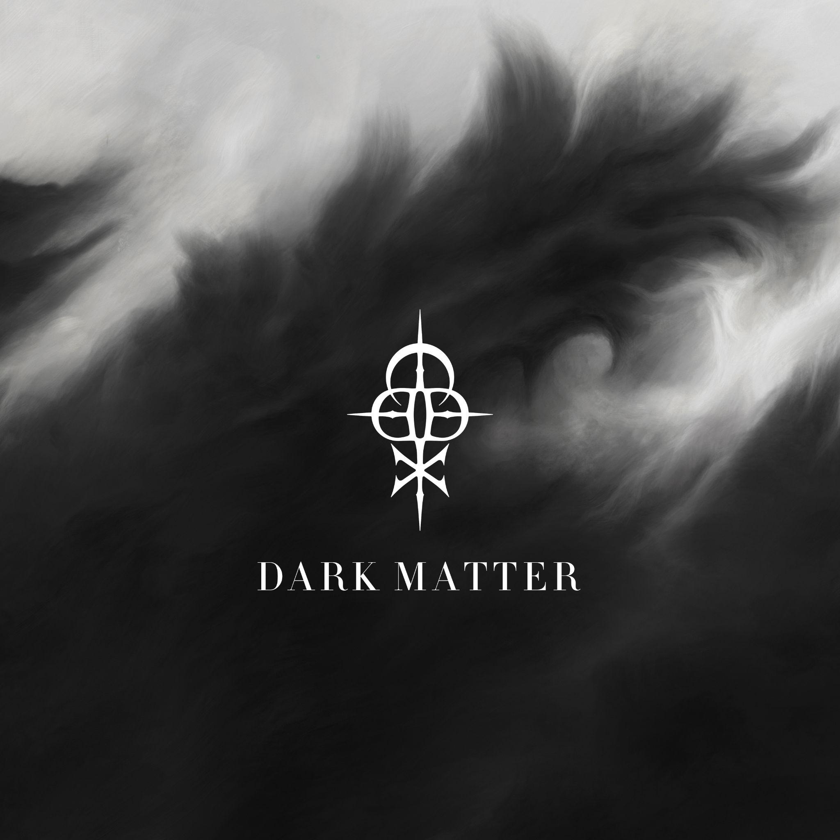
Title: Dark Matter
Artist: SEVERALS
Release date: 27th February 2026
ISRC: QZHNB2673004
Songwriters: Zdeněk Ziegler, Ondřej Dobrý, Jan Dietl, Dominik Fencl
Producer: Zdeněk Ziegler
Mix & master: Chris Kreutzfeldt
Artwork: Jan Dietl
Links:
Web: https://www.severalsofficial.com/home
YouTube | Spotify | Apple Music | Facebook | Instagram | TikTok

