



SEVERALS CONFRONT THE WEIGHT OF GUILT WITH NEW SINGLE "BLAME"

SEVERALS are a Czech band operating with tension, silence and impact as their core elements. They do not chase trends or instant gratification. Instead, they build a carefully constructed world where sound, image and intent are inseparable. Their music is physical, dark and deliberate. This is not background noise. This is an entry point.

The new single Blame represents the next crucial sequence in the band’s ever-evolving structure. Thematically and sonically, it delves into the uncompromising depths of denial, guilt, and self-deception. The track relentlessly explores the weight of unspoken apologies, the burden of blaming others, and the exhausting struggle of facing one's own faults and failures.

Lyrically, Blame manifests internal conflict and emotional turmoil through vivid metaphors of hiding behind shadows, drowning in denial, and painfully piecing together a mosaic of failures. There is nowhere left to hide. It is a direct confrontation - an inevitable mirror held up to one's own destruction.

Their visual language, pacing, and symbolism are once again tightly connected to the music, amplifying the sense of physical weight. SEVERALS demonstrate that their descent into darker, more personal territories is carefully calculated. Blame is a clear signal that the band continues to execute their vision with absolute precision and zero compromise.

Follow the Codex.
BLAME
Visualizer for Blame
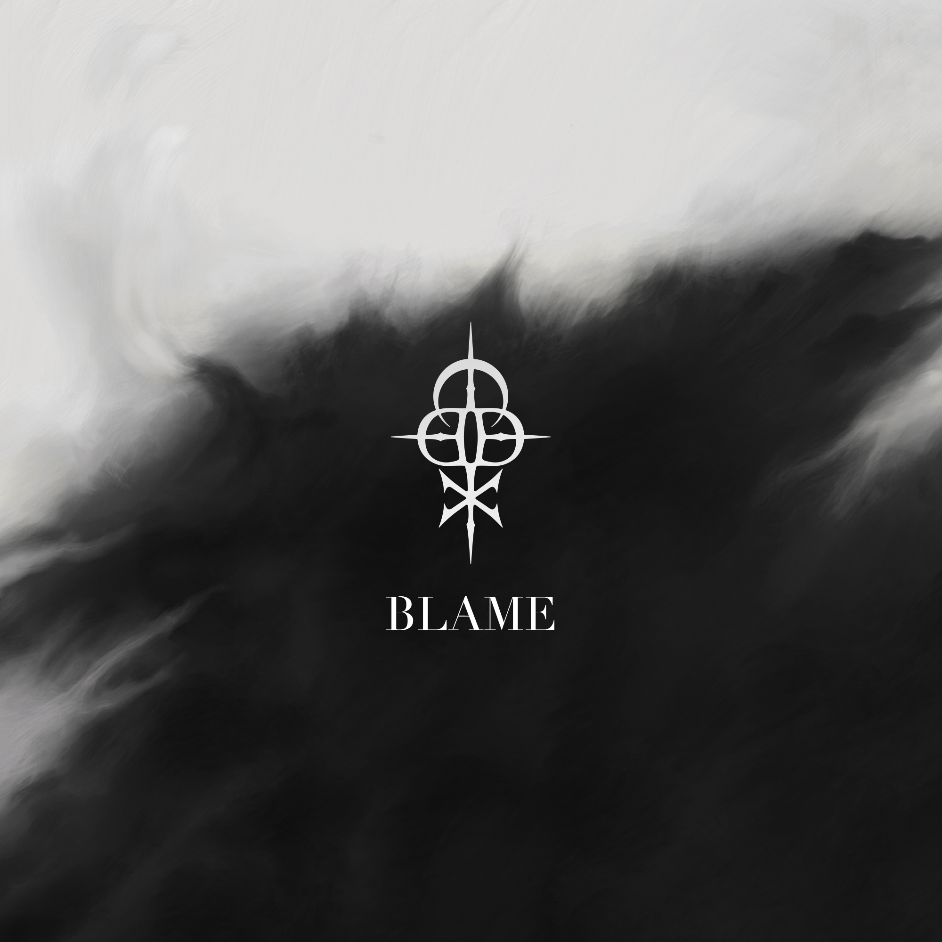
Title: Blame
Artist: SEVERALS
ISRC code: QZRP52691090
Release date: 3rd April 2026
Songwriters: Zdeněk Ziegler, Ondřej Dobrý, Jan Dietl, Dominik Fencl
Producer: Zdeněk Ziegler
Mix & master: Chris Kreutzfeldt
Artwork: Jan Dietl
Links:
Web: https://www.severalsofficial.com/home
YouTube | Spotify | Apple Music | Facebook | Instagram | TikTok

